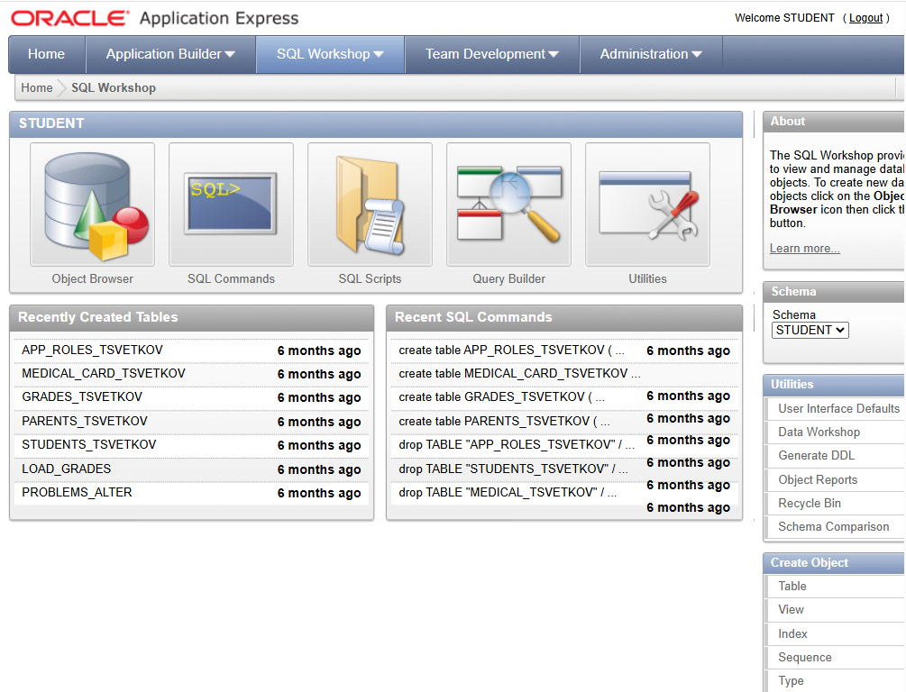
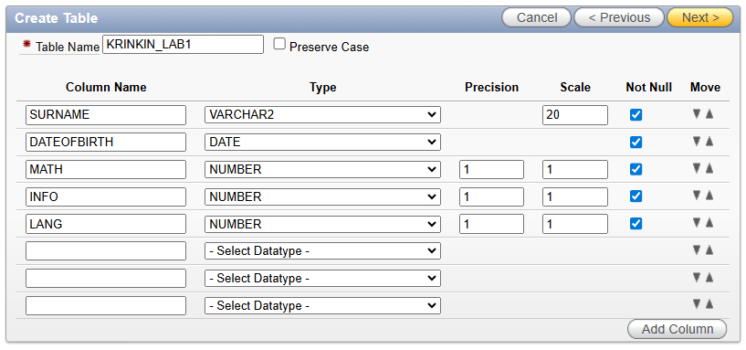
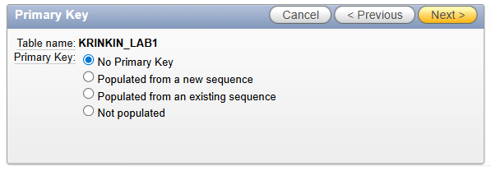
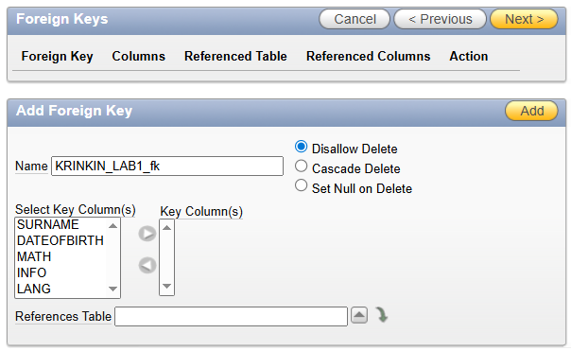
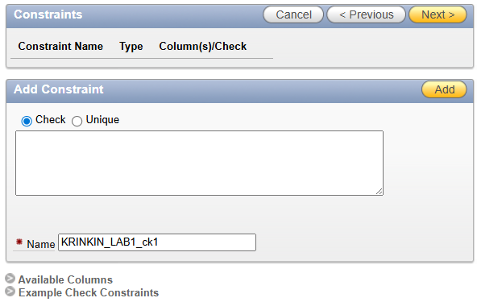
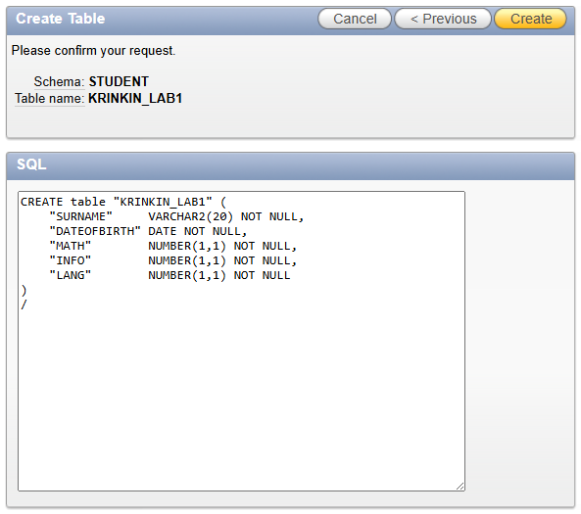
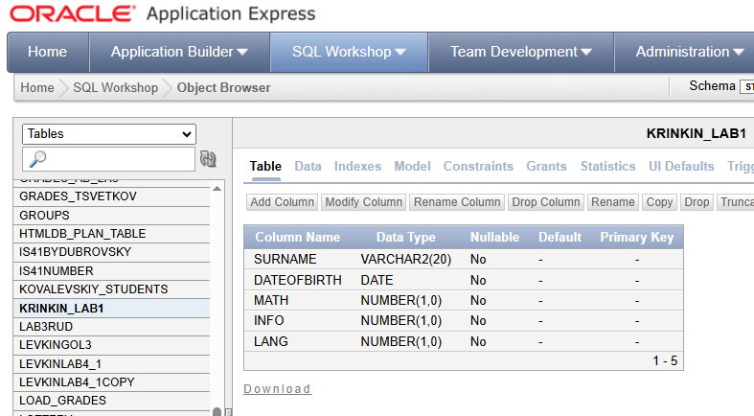
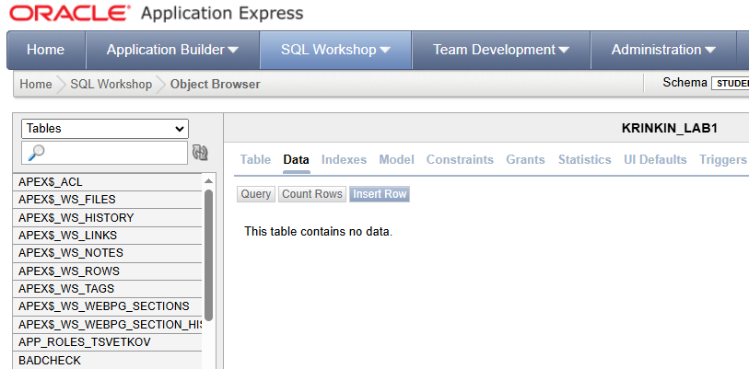
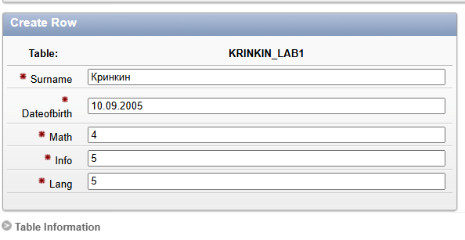
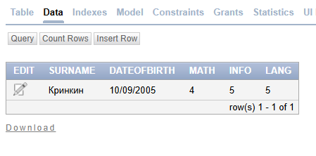
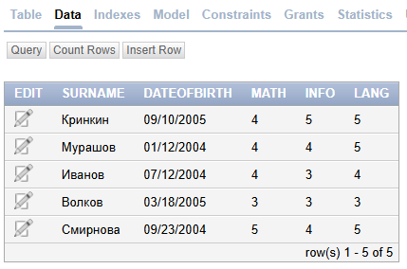
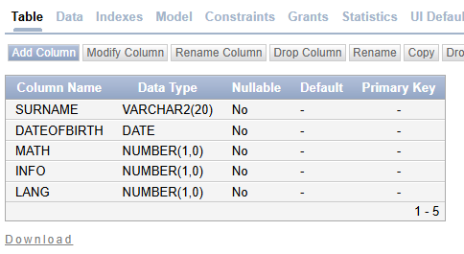
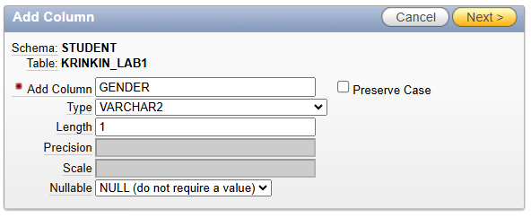
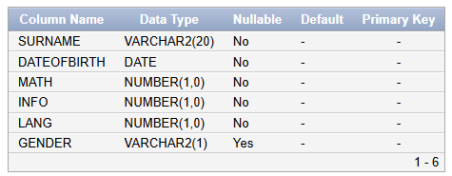
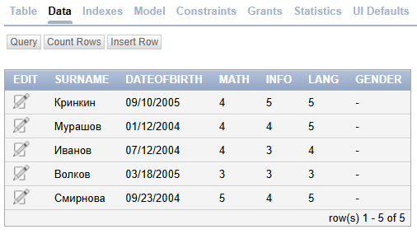
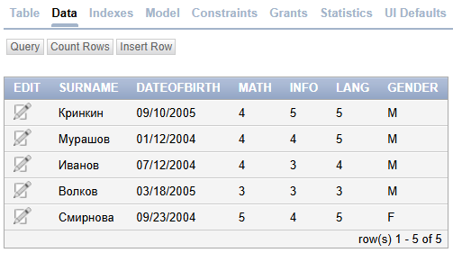
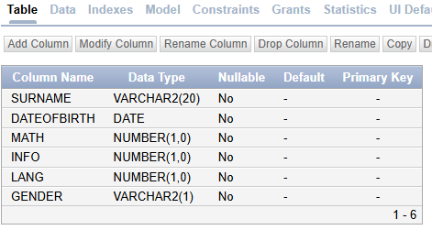
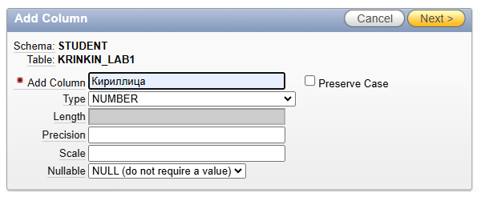
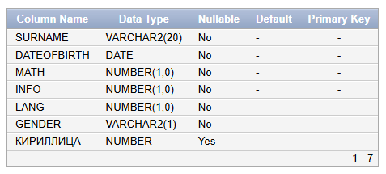
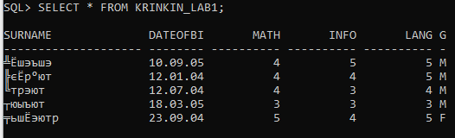
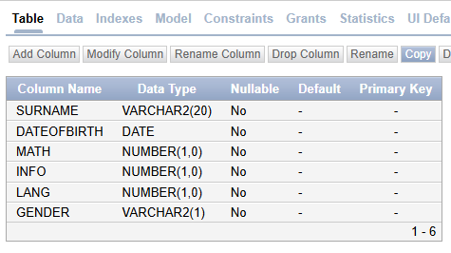
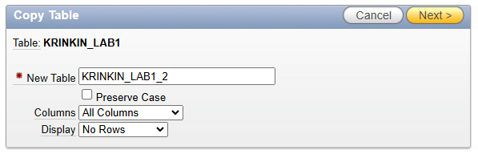
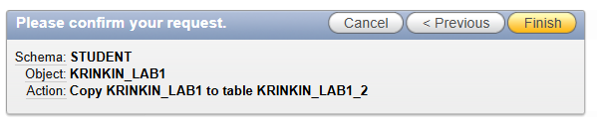
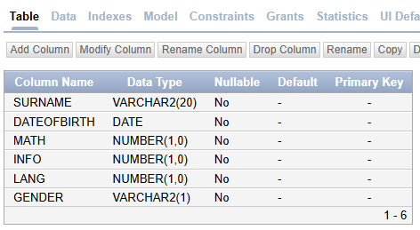
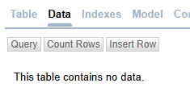
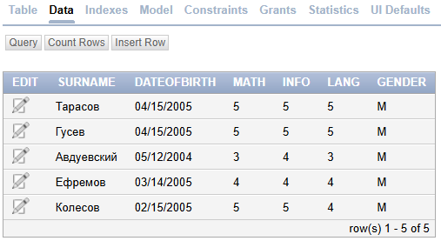
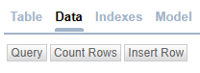
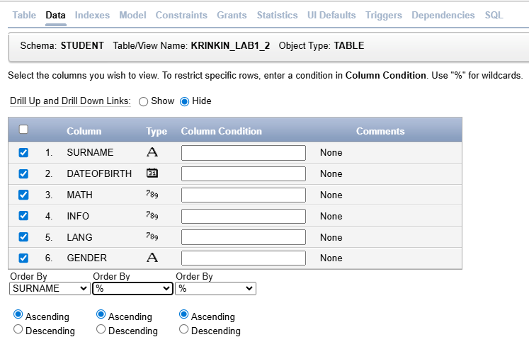
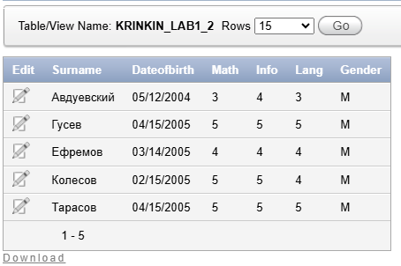
SELECT * FROM (
SELECT * FROM KRINKIN_LAB1
UNION
SELECT * FROM KRINKIN_LAB1_2
) WHERE SURNAME='Кринкин' AND DATEOFBIRTH='09/10/2005';
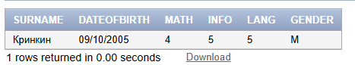
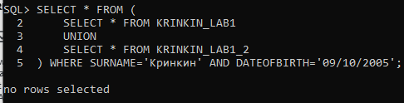

SELECT * FROM (
SELECT * FROM KRINKIN_LAB1
UNION
SELECT * FROM KRINKIN_LAB1_2
) WHERE MATH=5;
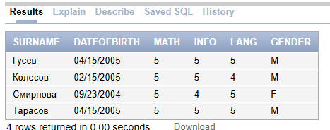

SELECT * FROM (
SELECT * FROM KRINKIN_LAB1
UNION
SELECT * FROM KRINKIN_LAB1_2
) WHERE MATH=5 AND INFO=5 AND LANG=5;
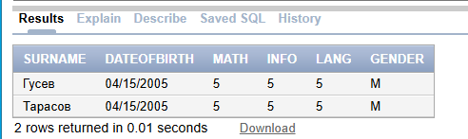

SELECT * FROM (
SELECT * FROM KRINKIN_LAB1
UNION
SELECT * FROM KRINKIN_LAB1_2
) WHERE MONTHS_BETWEEN(TRUNC(SYSDATE), DATEOFBIRTH) / 12 > 20;
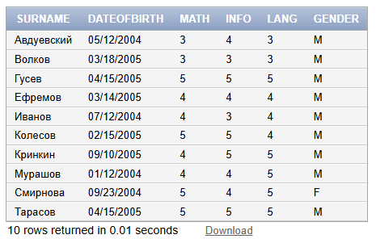

SELECT * FROM (
SELECT * FROM KRINKIN_LAB1
UNION
SELECT * FROM KRINKIN_LAB1_2
)
WHERE SURNAME=:Surname;
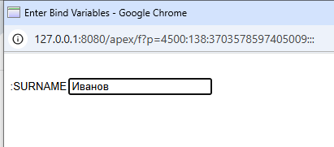
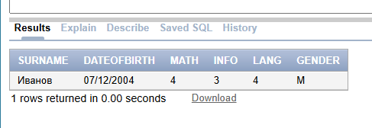
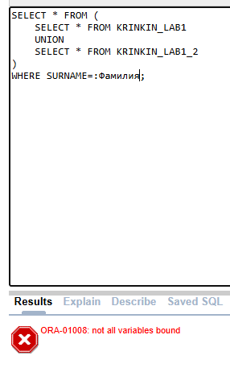

SELECT * FROM (
SELECT * FROM KRINKIN_LAB1
UNION
SELECT * FROM KRINKIN_LAB1_2
)
WHERE SURNAME=:Surname AND MATH=:Math;
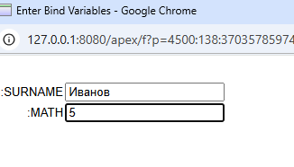
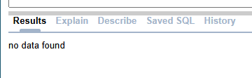

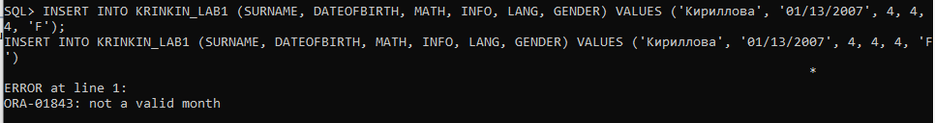
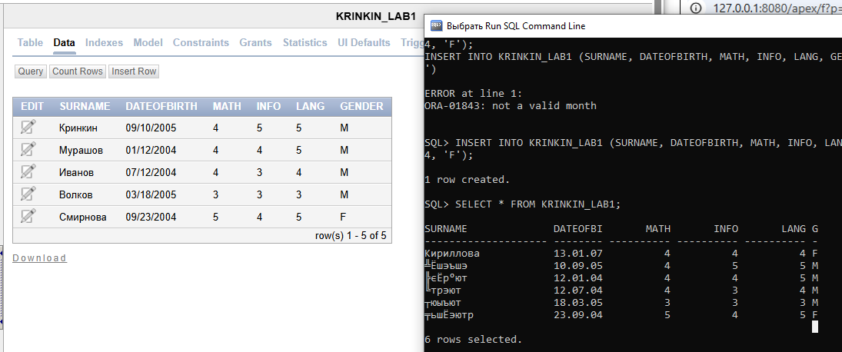
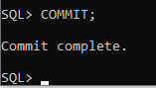
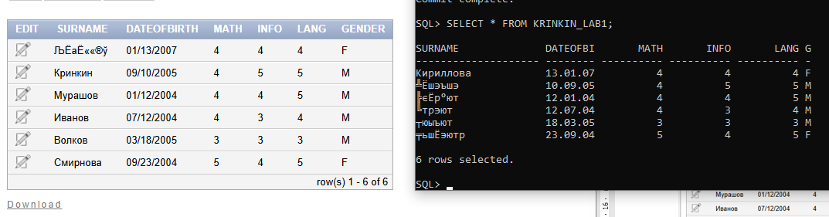
chcp 65001
set NLS_LANG=.AL32UTF8
sqlplus

